Excel Challenge

Homework week 1

Submission Date: 25/11/2020

Monash Data Boot Camp

Student: Franz Kiel

Table of Contents

Kickstart My Chart 2

1. Database 2

2. Categories 3

2.1. Parent Categories 3

2.2. Sub-Categories 4

3. Creation Month 5

4. BONUS – Goal 6

5. Bonus – Statistics 6

5.1. Box and Whisker 7

5.2. Box and Whisker – same scale 7

# Kickstart My Chart

Over $2 billion has been raised using the massively successful crowdfunding service, Kickstarter, but not every project has found success. Of the more than 300,000 projects launched on Kickstarter, only a third have made it through the funding process with a positive outcome.

## Database

The provided database contains 4,114 of past projects that were created between 2009 on 2017.

In this period, 2015 was the strongest year by number of Total Projects and in each outcome category. Though it needs to be considered that 2009 and 2017 are incomplete years.



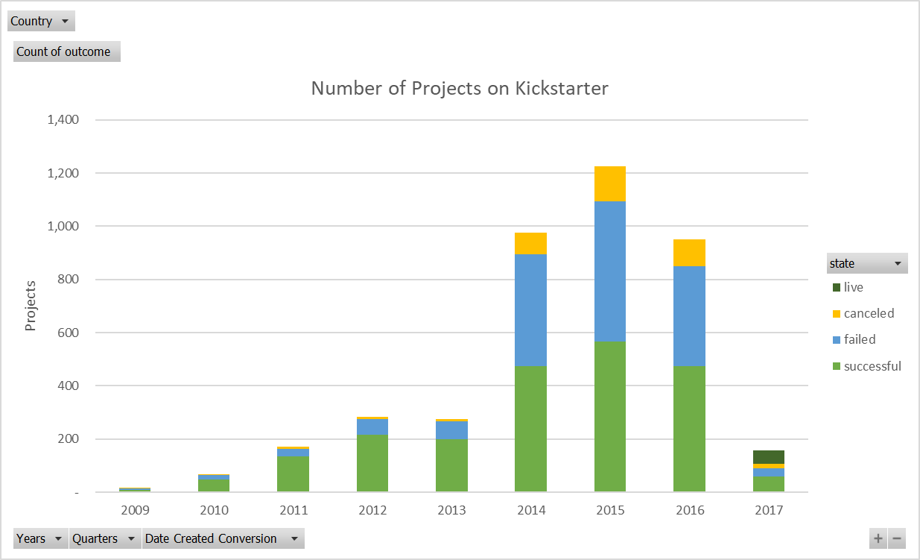

## Categories

The projects can be categorised in parent-categories and sub-categories.

## Parent Categories

There are 9 Parent-Categories. The most projects occurred in theatre (1,393), followed by music (700) and technology (600). Journalism is the only category with no completed project, they were all cancelled before.



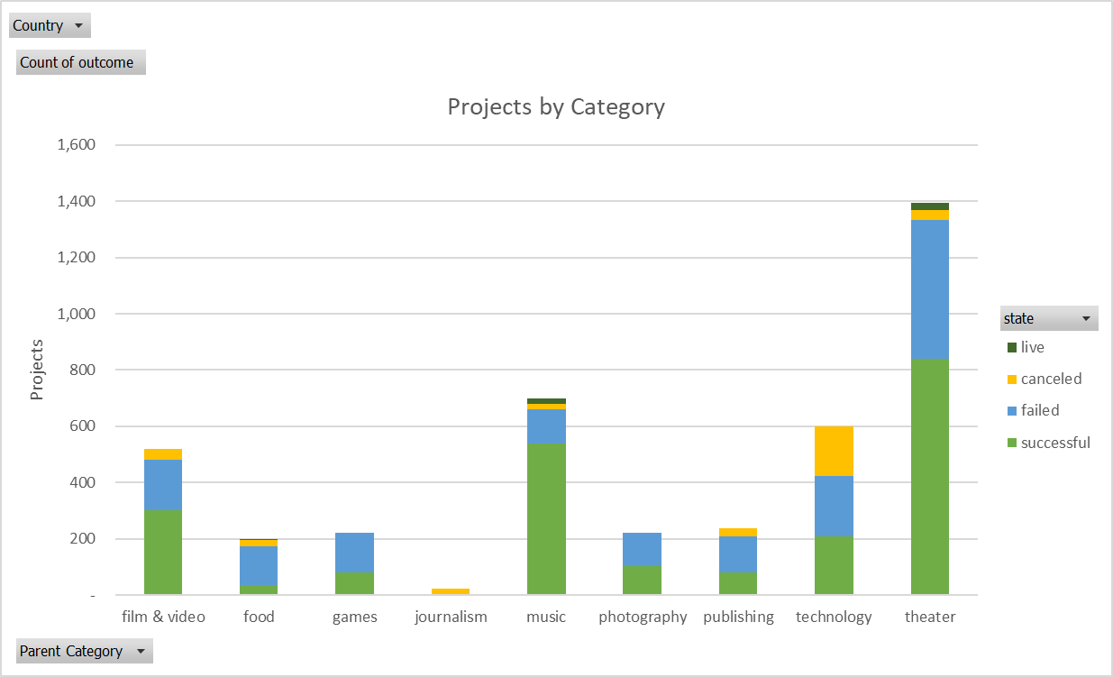

## Sub-Categories

There are 41 Sub-Categories of which plays is by far the strongest by number of projects. Australia has only 25 Sub-Categories, but plays is still the strongest by number.

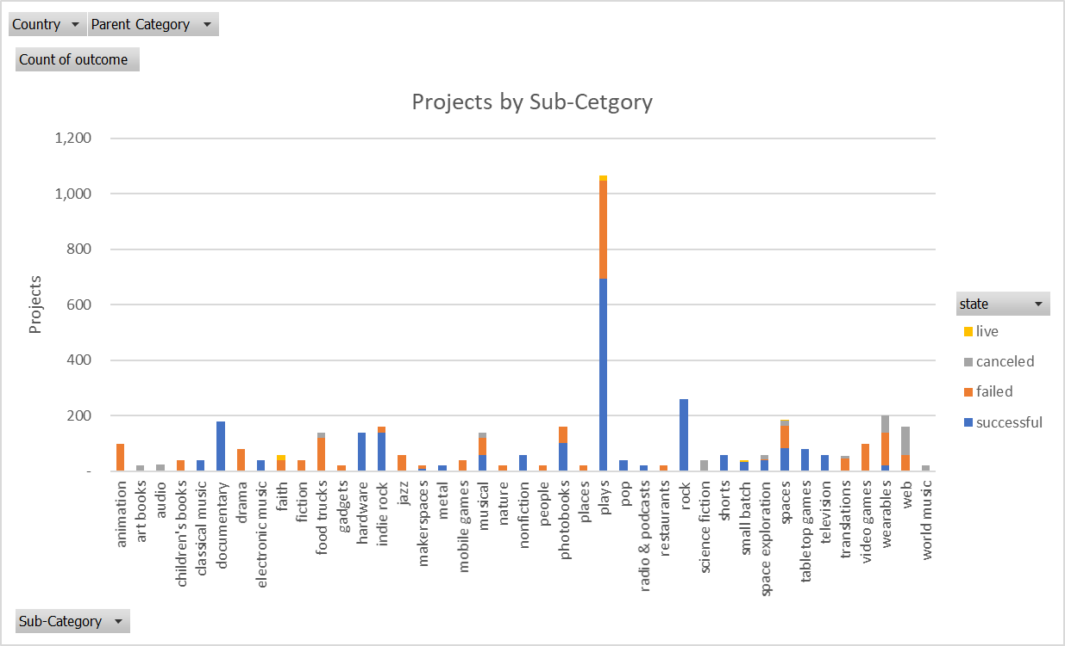

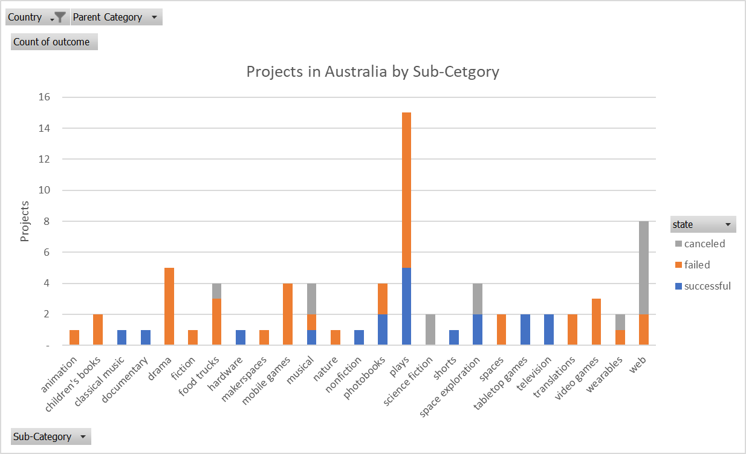

## Creation Month

Most projects were created in the 3 months of May, June, and July. The most successful projects were created in May.

December counts for the lowest number of projects created. A potential reason could be the Christmas break in most countries were Kickstarter operates.



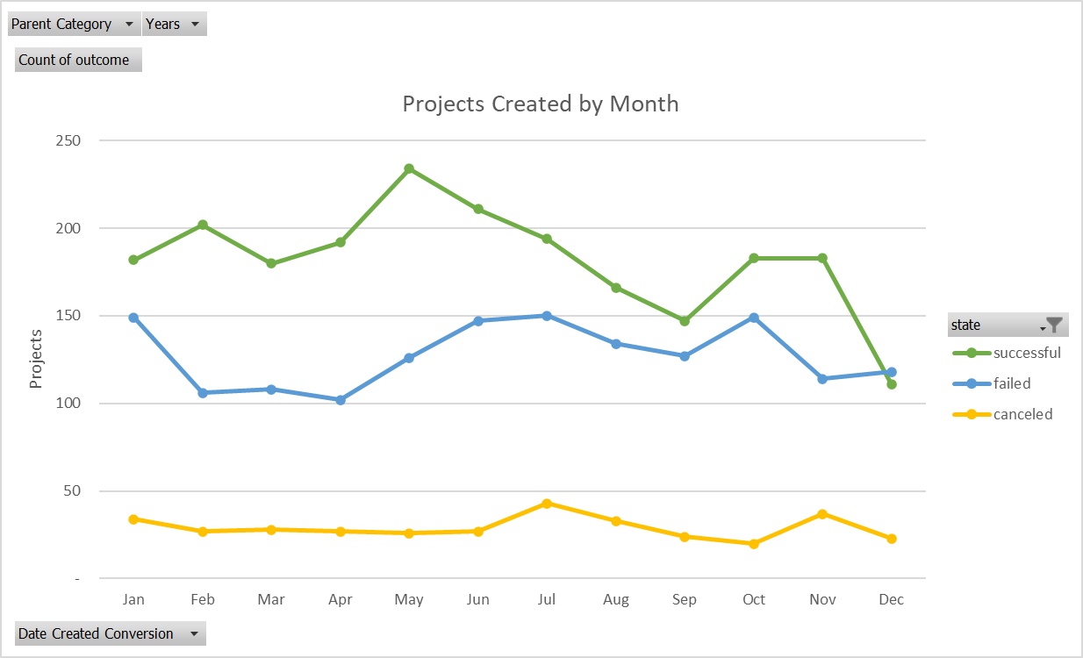

## BONUS – Goal

The following graph shows a negative correlation between the raise goal and a successful outcome. This means that projects with a lower goal have a higher probability of success.

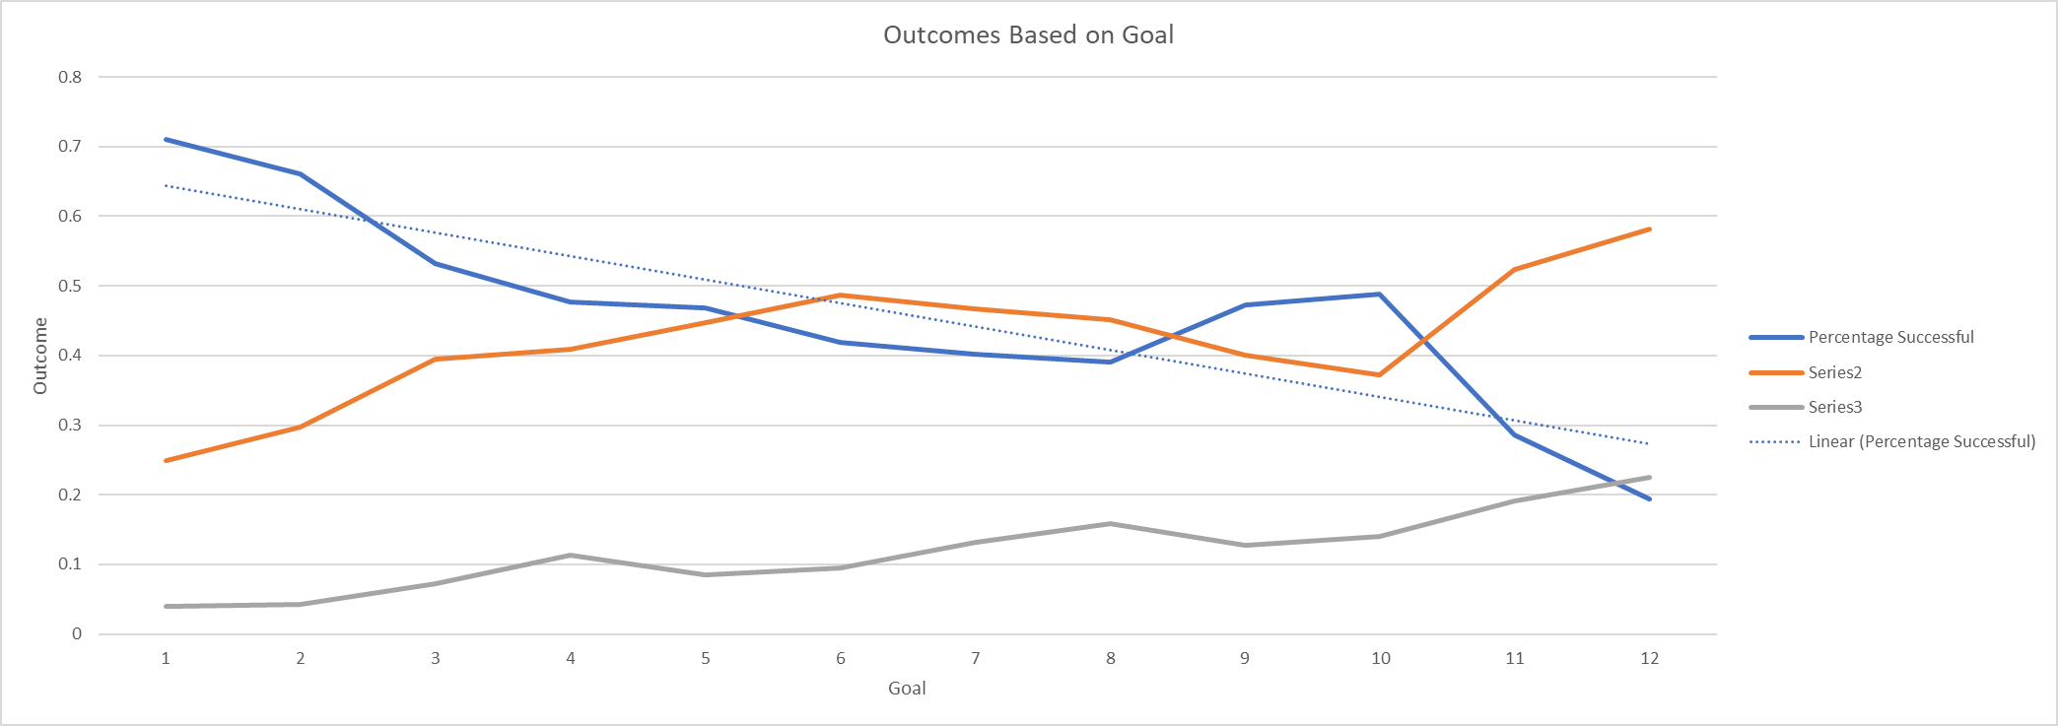

## Bonus – Statistics

Both failed and successful outcomes have a significant number of outliers as you can see in the Box and Whisker charts below. Therefor the median is a better measure to summarize this data meaningfully.

Successful projects had a median of 62 backers. As you could expect, failed projects have a lower median number of backers (4). The significant difference of 58 could indicate that projects are either successful or fail by far. It could be explained with herd mentality, people like o follow other investors.



### Box and Whisker

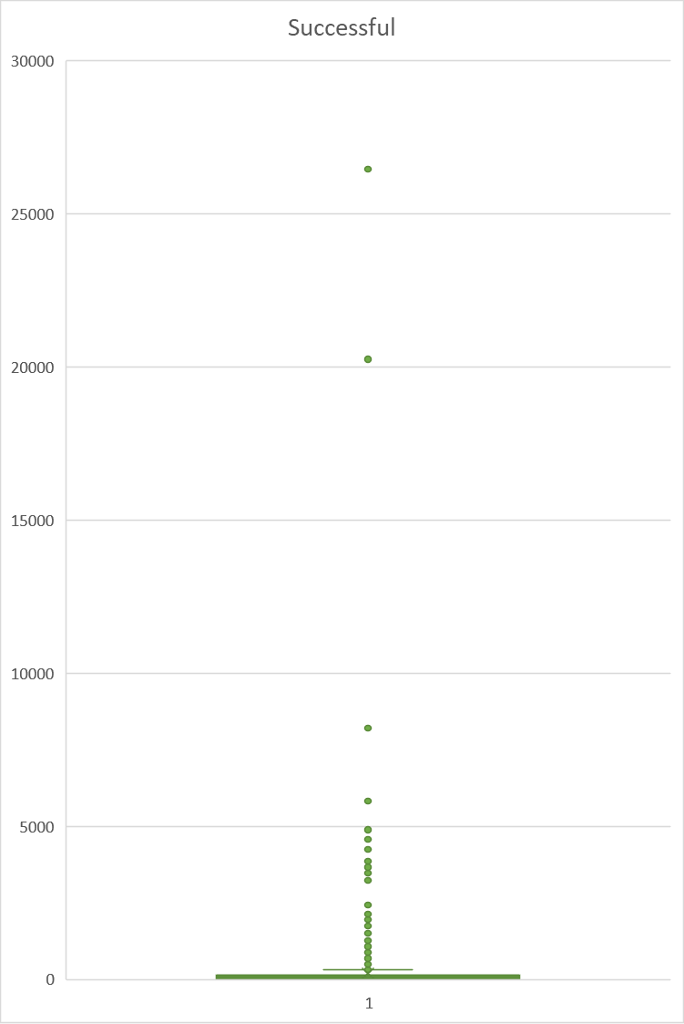 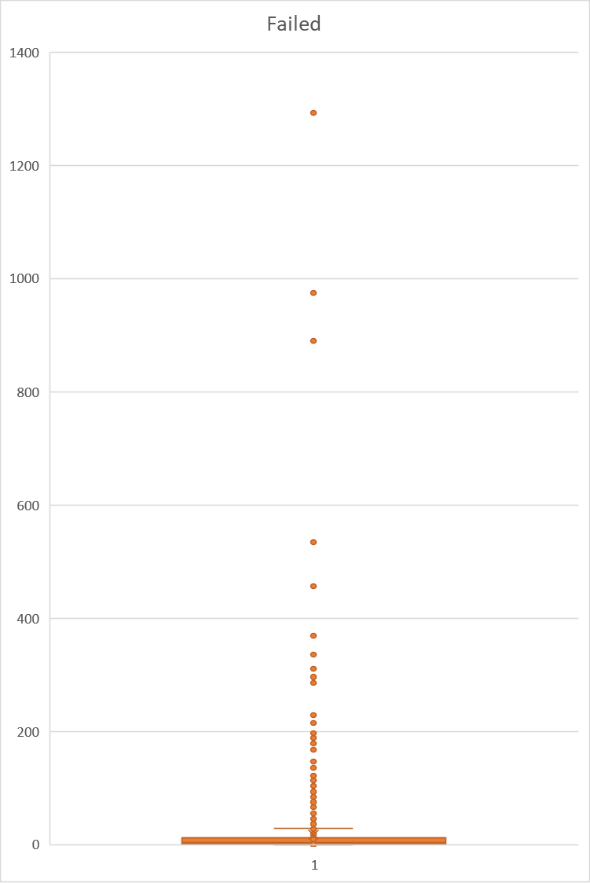

### Box and Whisker – same scale

